Dr. A. Q. Khan Institute of Computer Science & Information Technology


Lab no. 02
Artificial Intelligence (Lab)

Submitted to:
MAM HAJRA
Submitted by:
Tehzeeb (232101006)
Department:
BSCE-7.
Date:
September 9th, 2026

Coding/logic | Response | Data processing & visualization | Accuracy | Outcome/Result
04 | 04 | 04 | 04 | 04
LINK: https://github.com/Tehzeb/AI-LAB/tree/main/LAB2

Question 1
Practice fundamental Artificial Intelligence concepts using Python and Demonstrate their application by loading, processing, and analyzing the Kaggle Crop Recommendation Dataset, which contains soil and environmental features including Nitrogen (N), Phosphorus (P), Potassium (K), temperature, humidity, pH, and rainfall for data-driven crop recommendation. Execute Python programs using variables, data types, operators, conditional statements, loops, functions, and lists to calculate meaningful statistics, classify agricultural conditions, and generate data-driven results. Analyze the selected soil and environmental parameters to identify patterns and relationships that can support informed agricultural decision-making. Evaluate how Python-based data analysis can contribute to precision agriculture, efficient resource utilization, and sustainable crop-selection decisions.
This activity develops specialist AI knowledge (WK4) by applying Python-based computational concepts to a real-world engineering problem and develops EC1 (Comprehend and apply universal knowledge) and EC2 (Comprehend and apply local knowledge) through data-driven analysis of agricultural and environmental conditions. The activity supports PLO-02 (Problem Analysis) by requiring students to identify, investigate, and analyze a real-world problem using data and computational logic, while contributing to SDG 9 (Industry, Innovation and Infrastructure) through the application of digital and AI-based technologies for innovative and efficient agricultural practices.

Task Requirements
- Download the specified Kaggle Crop Recommendation Dataset and load it into the Python environment.
- Identify and document:
  - Number of records and features
  - Column names and data types
  - Minimum, maximum, and average values of at least three numerical features
  - Different crop categories available in the dataset
- Use Python fundamentals including:
  - Variables and data types
  - Arithmetic, relational, and logical operators
  - if-elif-else
  - for and/or while loops
  - User-defined functions
  - Lists and list operations
- Develop a Python program that analyzes at least three agricultural features, such as N, P, K, temperature, humidity, pH, or rainfall, and produces meaningful results such as:
  - Soil nutrient condition
  - Suitable environmental condition
  - Crop-related category
  - Average environmental condition for selected crops
- Identify at least two meaningful patterns or observations from the generated results and explain their possible relevance to crop selection and agricultural decision-making.
- Introduce or identify at least one syntax, logical, or runtime error, troubleshoot it, execute the corrected program, and document the original error, cause, correction, and final result.
[CLO- 01, PLO-02, P3 (Practice) , WK4, EC1, EC2 and SDG 9 Rubric (Design , (Outcome) Points (12)]

CODE:
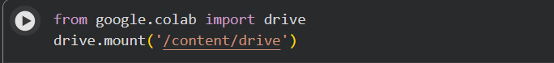
OUTPUT:

CODE:
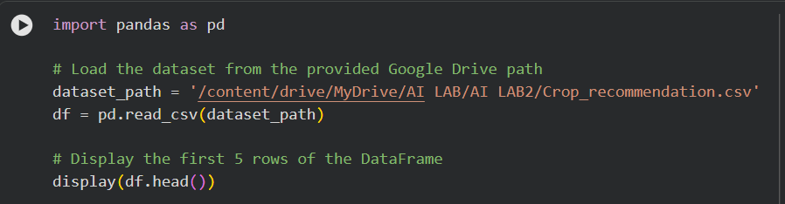
OUTPUT:
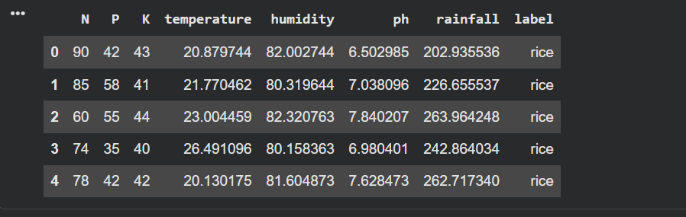
CODE:
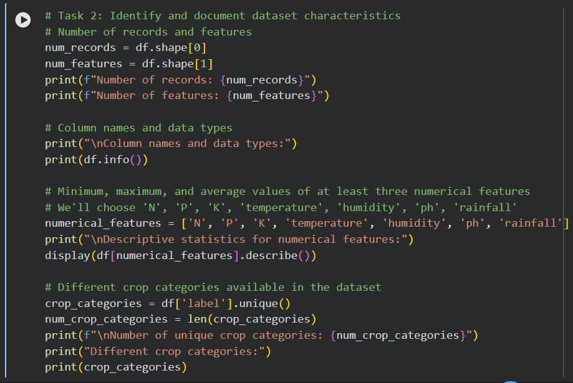
OUTPUT:
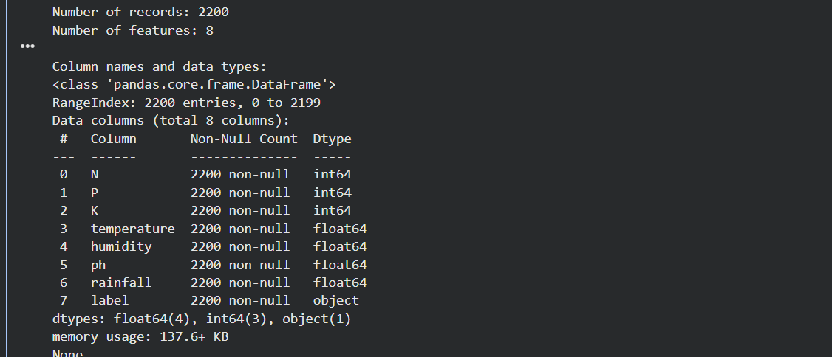
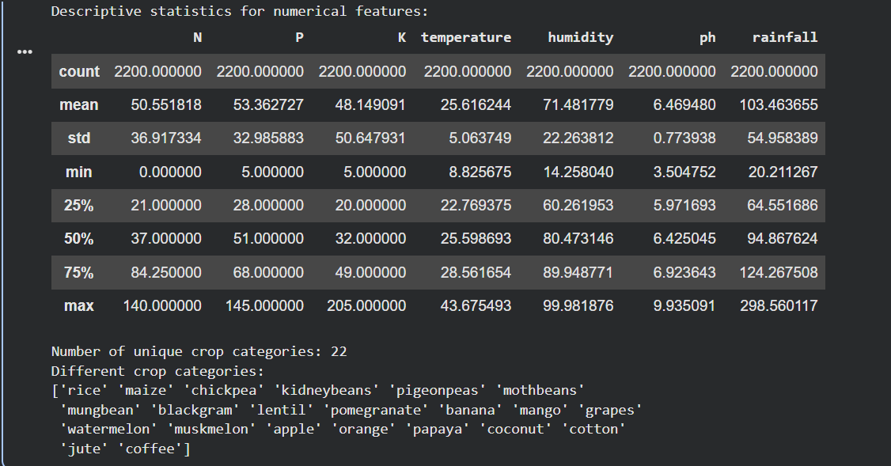

Task 3 & 4: Develop a Python program for agricultural analysis
I will create a function recommend_crop that takes N, P, K, temperature, humidity, pH, and rainfall as inputs. This function will classify the soil nutrient condition, suitable environmental condition, and recommend a crop based on these parameters. I will also calculate the average environmental conditions for each crop type in the dataset to provide a baseline for recommendations.
CODE:
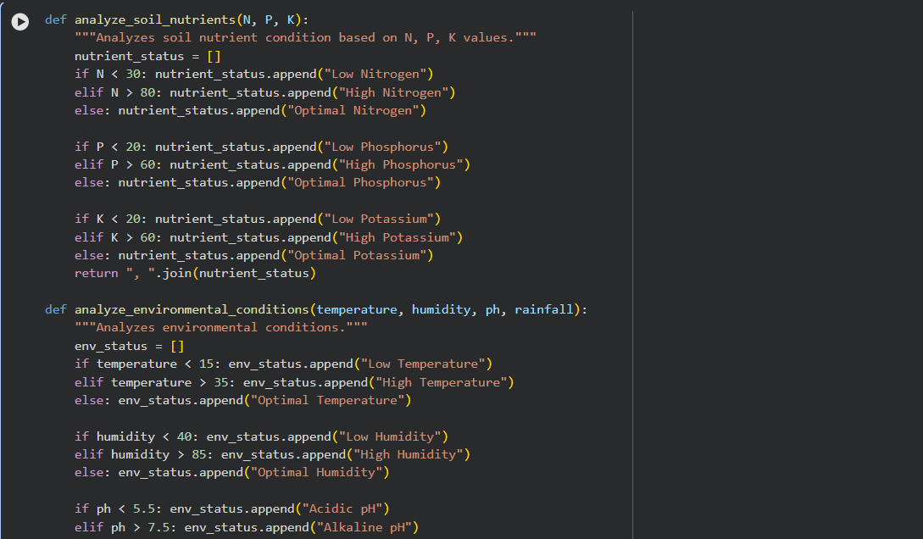
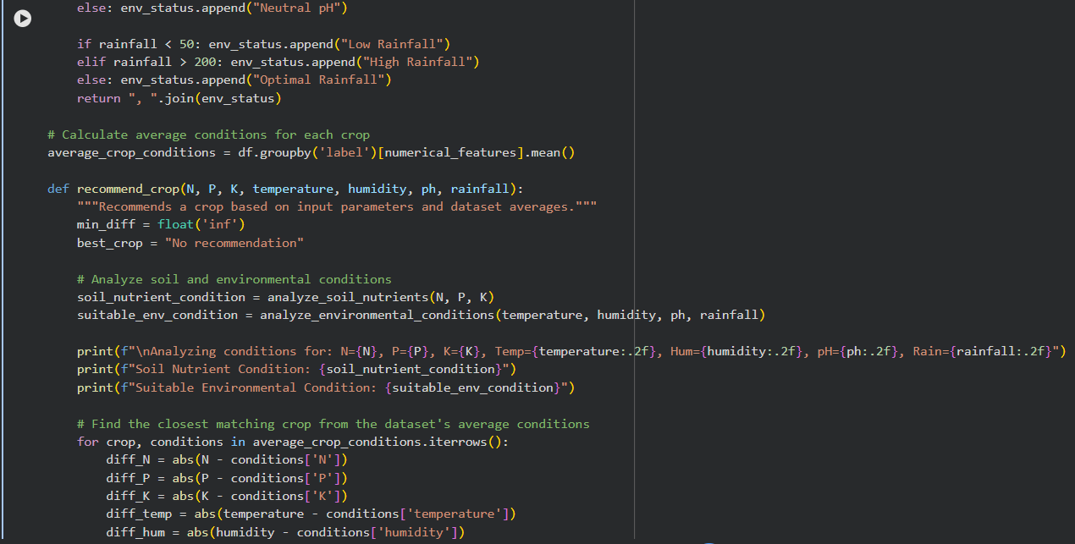
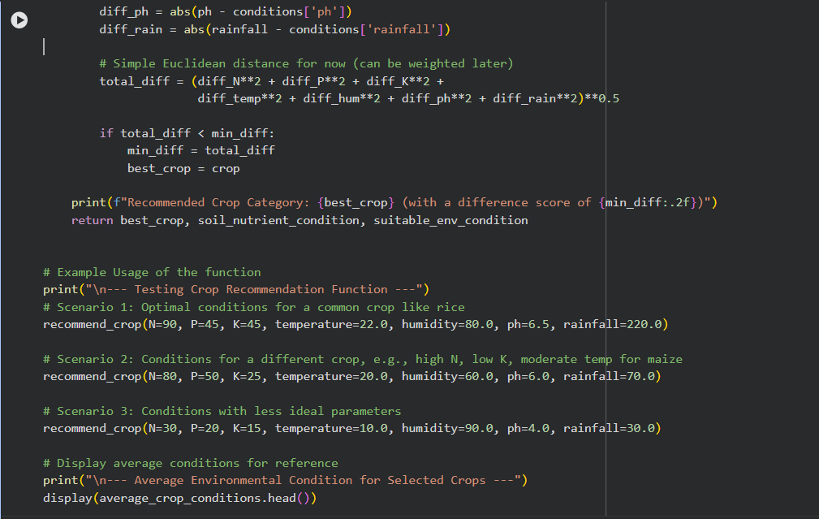
OUTPUT:
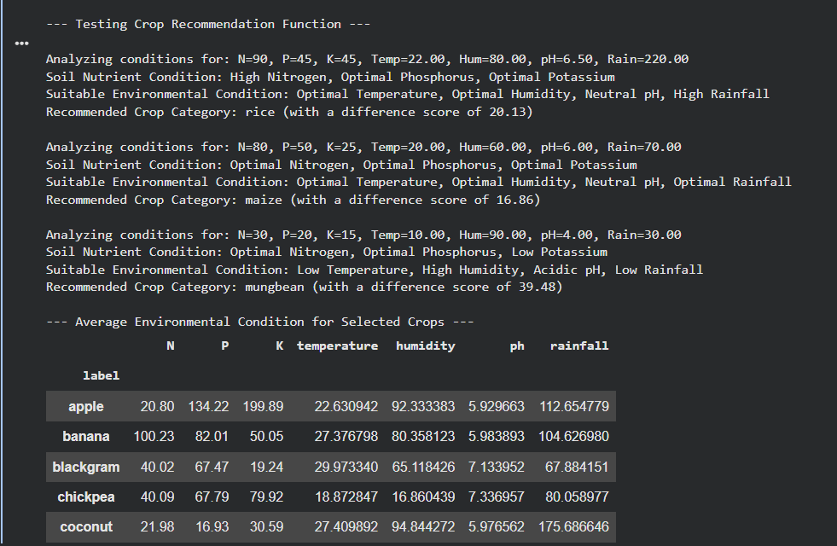
Task 5: Identify meaningful patterns and their relevance
Pattern 1: Specific Environmental Conditions Drive Crop Suitability
Observation:
- The recommendation for 'rice' in Scenario 1 was strongly correlated with 'High Rainfall' (220 mm), aligning with rice's known water requirements. The analysis function correctly identified this as an 'Optimal Temperature', 'Optimal Humidity', 'Neutral pH', but importantly 'High Rainfall' condition.
- Conversely, for 'mungbean' in Scenario 3, the conditions were characterized by 'Low Temperature', 'High Humidity', 'Acidic pH', and 'Low Rainfall'. The recommendation for mungbean suggests its tolerance or preference for such less-than-ideal or specific environmental extremes.
Relevance to Crop Selection and Agricultural Decision-Making:
This pattern highlights the critical importance of matching crop types to prevailing environmental conditions. Farmers can use this information to:
- Optimize resource utilization: By selecting crops like rice for high rainfall areas, they can leverage natural water resources efficiently and reduce the need for supplemental irrigation.
- Enhance crop resilience: For areas with challenging conditions (e.g., low rainfall, acidic soil, low temperature), identifying tolerant crops like mungbean (in the example) can help ensure agricultural productivity and food security.
- Informed land use: This analysis guides farmers in making informed decisions about which crops are best suited for particular land plots, considering local climate, humidity, and rainfall patterns, thereby improving overall farm productivity and sustainability.
Pattern 2: Distinct Soil Nutrient Profiles for Different Crops
Observation:
- The analyze_soil_nutrients function consistently identifies optimal and sub-optimal levels of N, P, and K. For instance, Scenario 1's rice recommendation came with 'High Nitrogen, Optimal Phosphorus, Optimal Potassium'. Scenario 3's mungbean recommendation was associated with 'Low Potassium'.
- Further examination of the average_crop_conditions DataFrame (e.g., the .head() displayed previously) shows clear differences: apple typically thrives with very high phosphorus (134.22) and potassium (199.89), while coconut requires much lower levels of N (21.98), P (16.93), and K (30.59) on average.
Relevance to Crop Selection and Agricultural Decision-Making:
This pattern underscores that each crop has a unique nutritional requirement profile. Understanding these profiles is vital for:
- Precision fertilization: Farmers can conduct soil testing and apply fertilizers precisely to meet the specific NPK demands of their chosen crop, reducing waste and environmental impact from overuse of fertilizers.
- Crop rotation and soil health: Knowledge of a crop's nutrient needs can inform crop rotation strategies. For example, following a heavy N-consumer with a legume (like mungbean, which can fix nitrogen) can naturally replenish soil nutrients.
- Yield optimization: By ensuring the soil's nutrient content is aligned with the crop's optimal range, farmers can significantly improve yields and crop quality, leading to better economic outcomes.
These patterns demonstrate how data-driven analysis of soil and environmental parameters can empower farmers with actionable insights for more efficient, sustainable, and productive agriculture.

CODE:
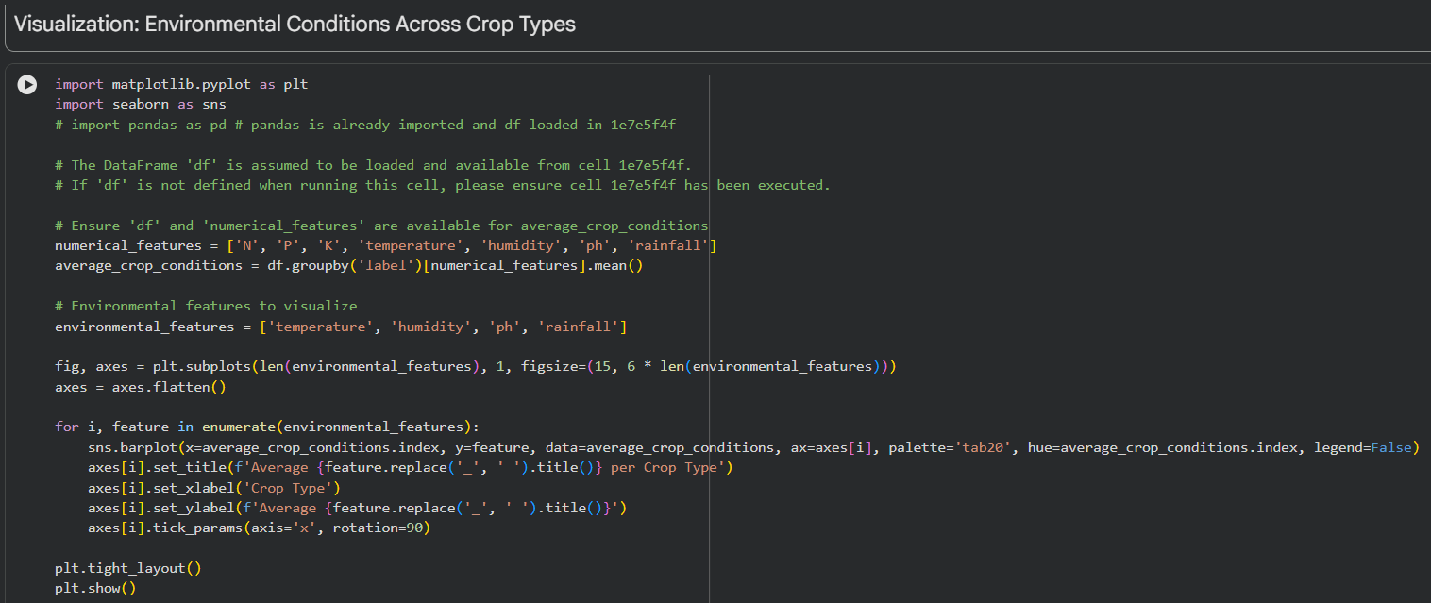
OUTPUT:
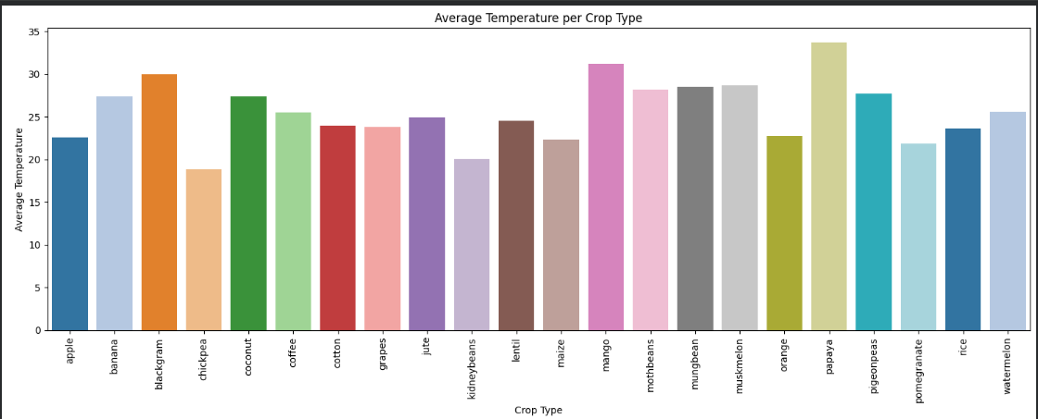
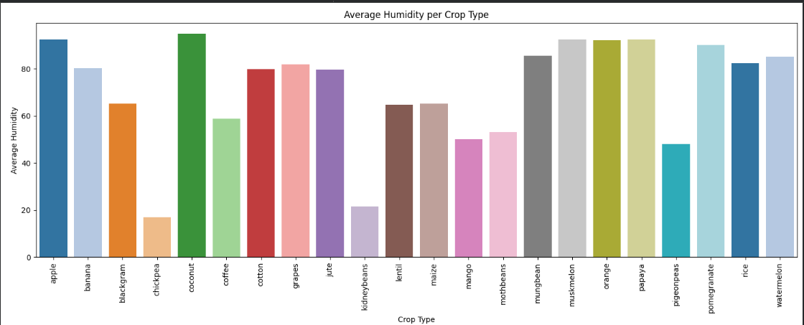
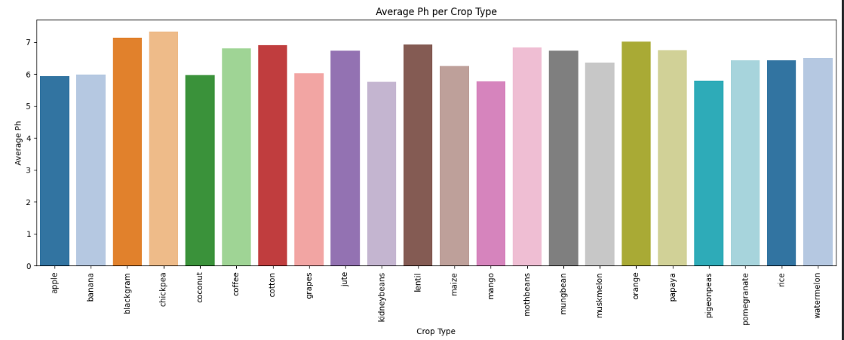
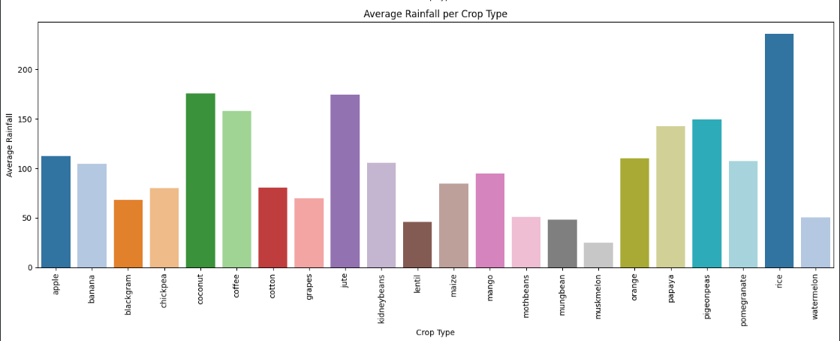

CODE:
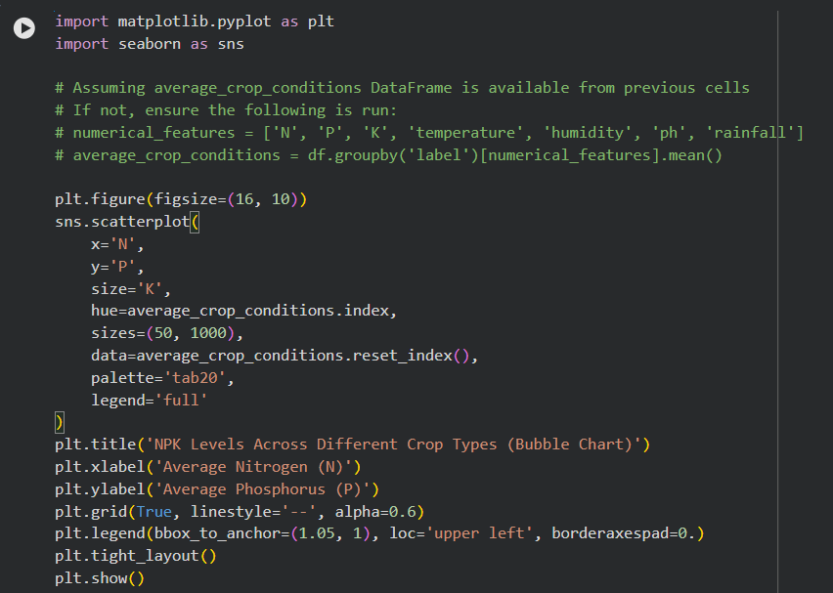
OUTPUT:
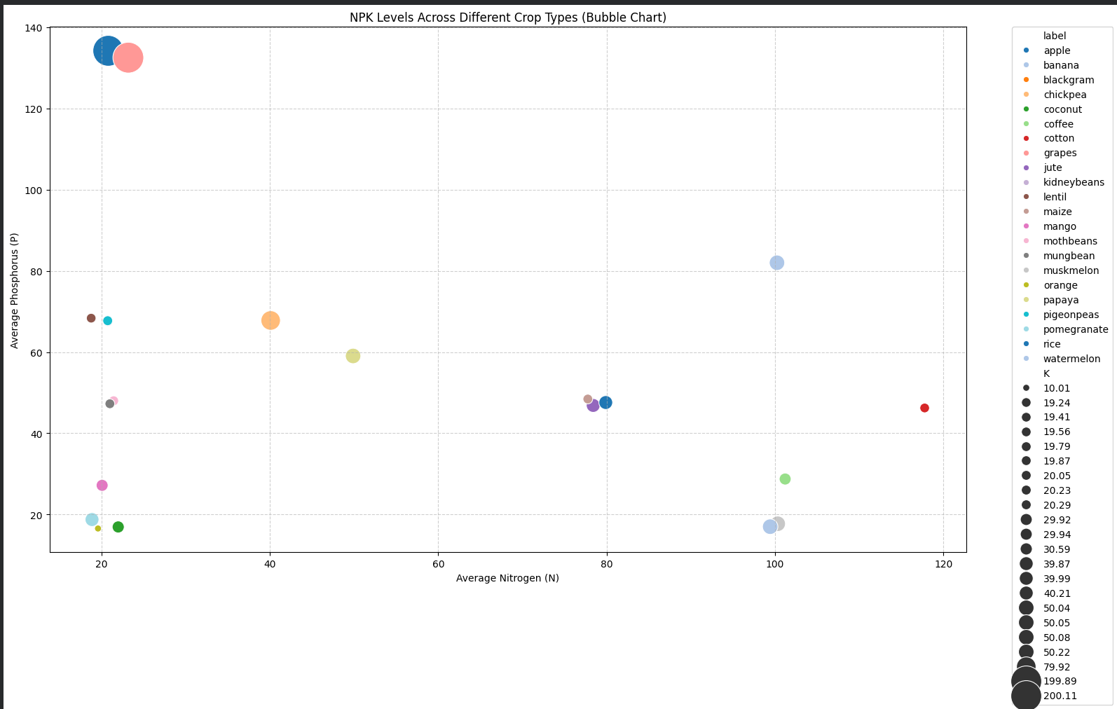
CODE:
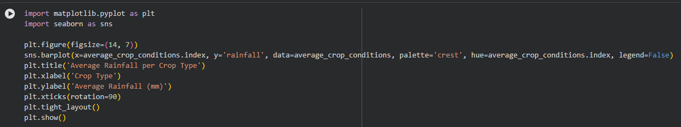
OUTPUT:
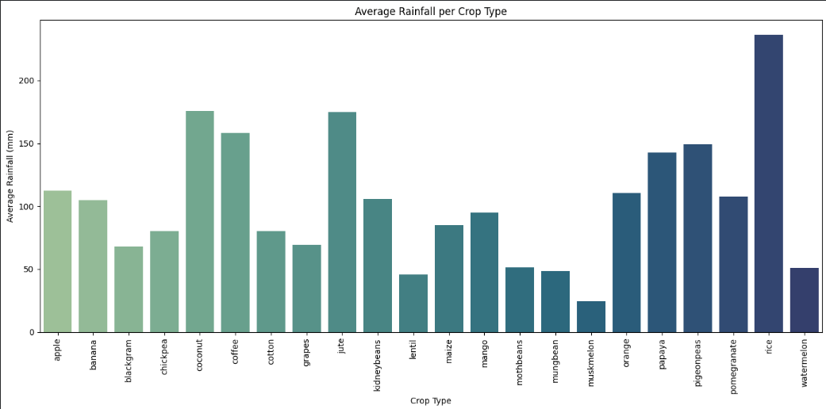
CODE:
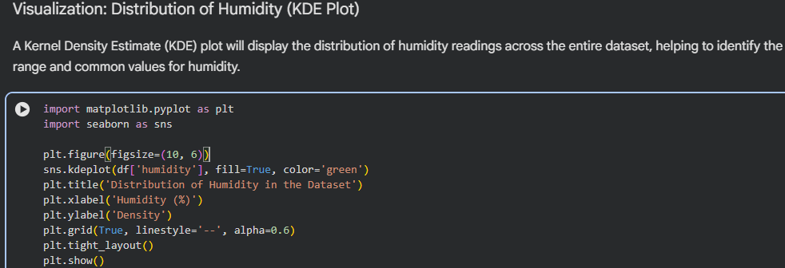
OUTPUT:
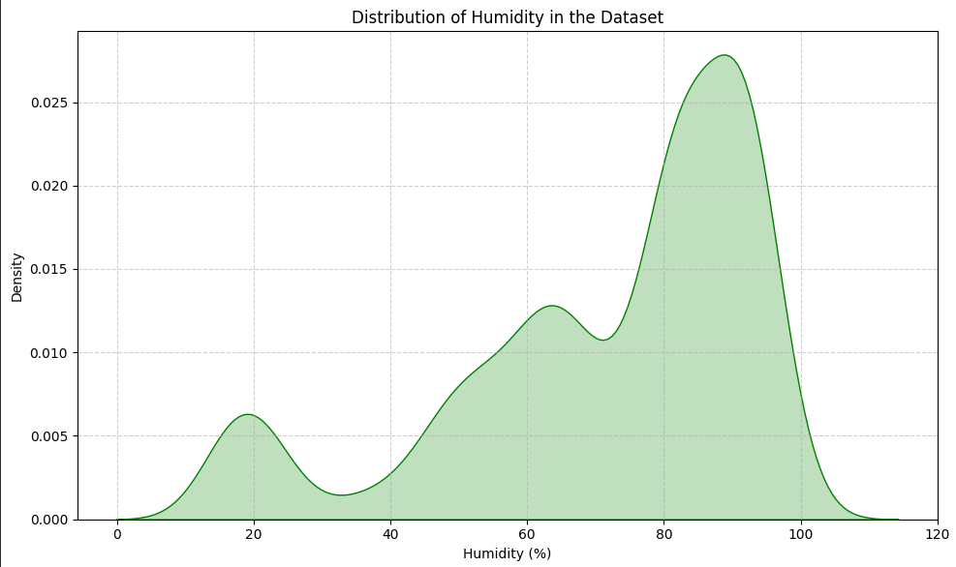
CODE:
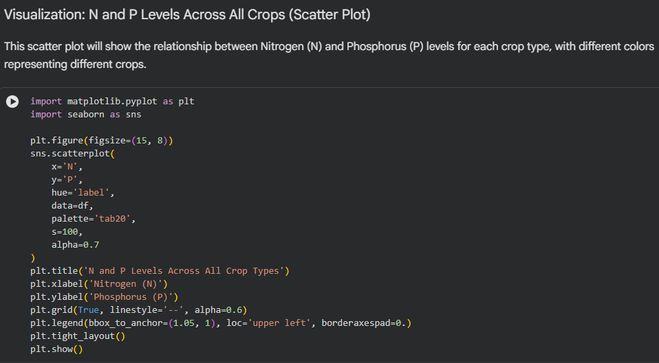
OUTPUT:
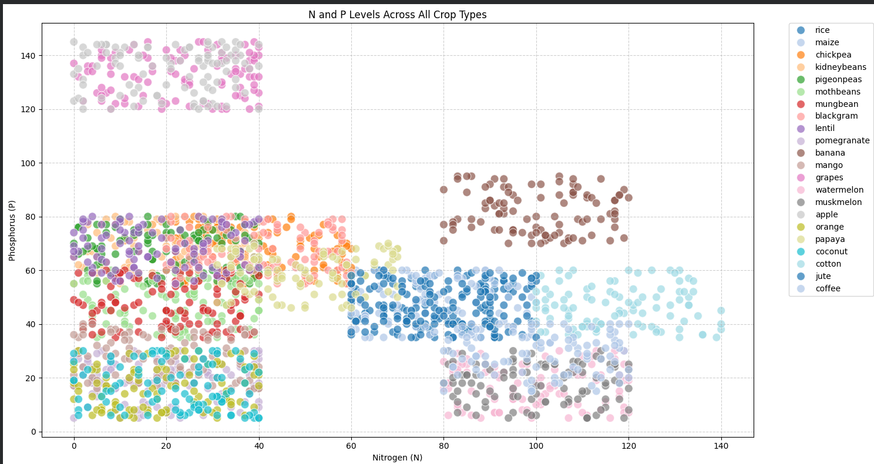
CODE:
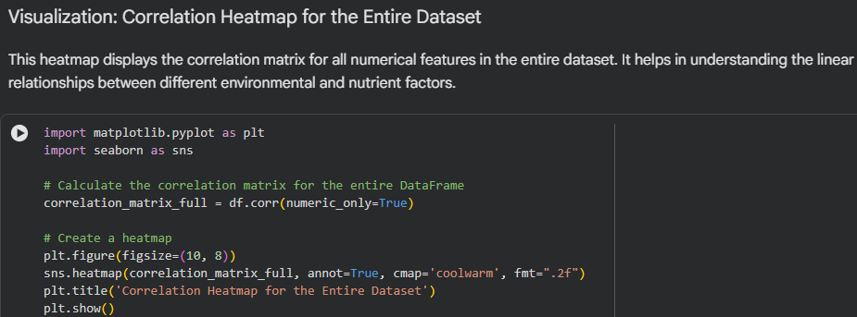
OUTPUT:
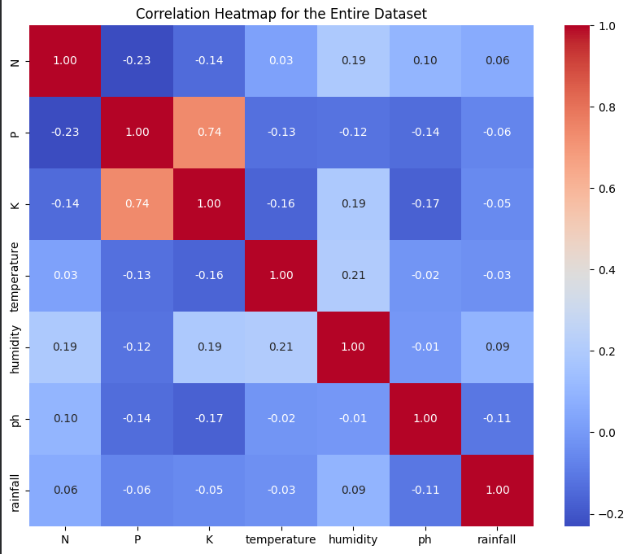
CODE:
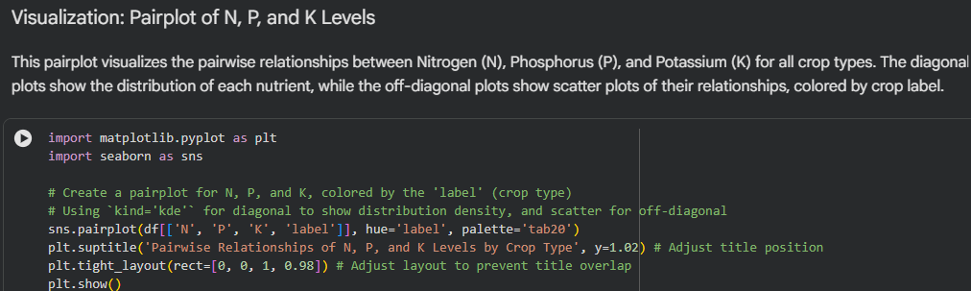

OUTPUT:
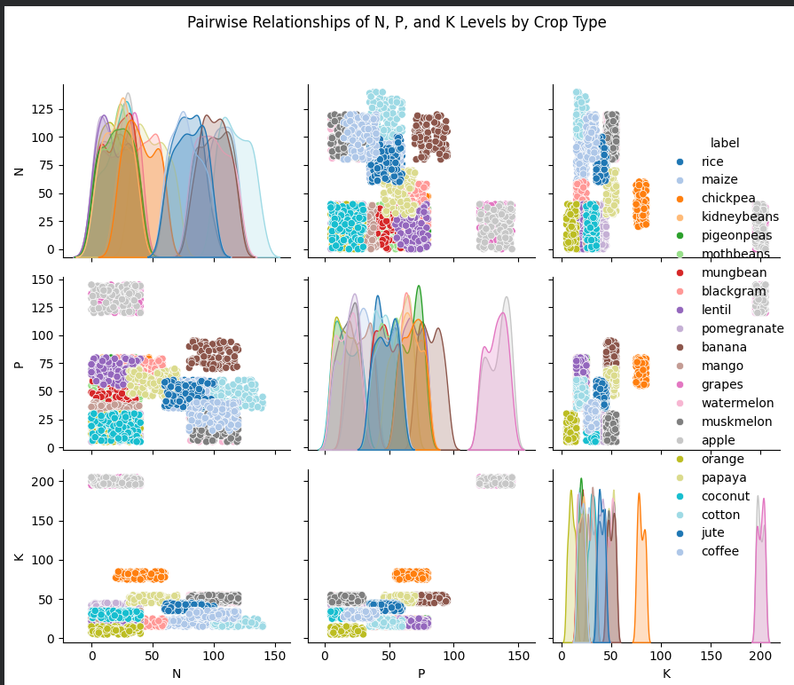

CODE:
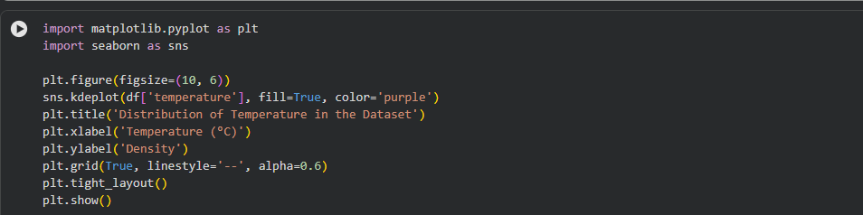

OUTPUT:
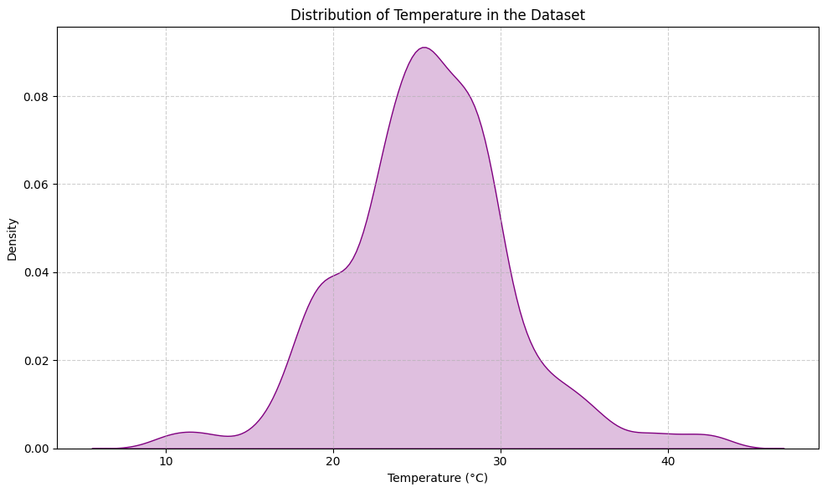
CODE:
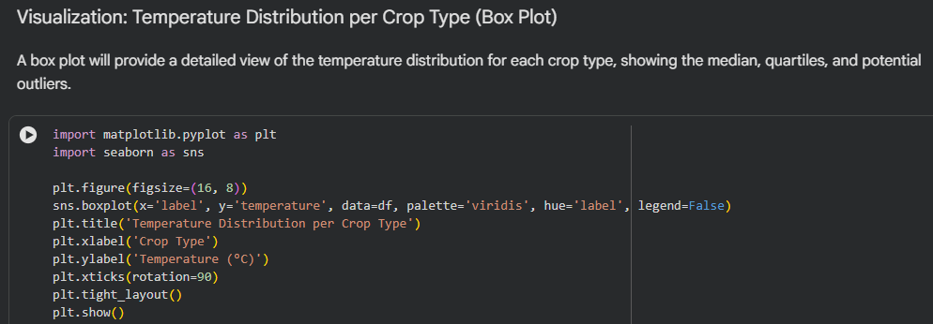
OUTPUT:
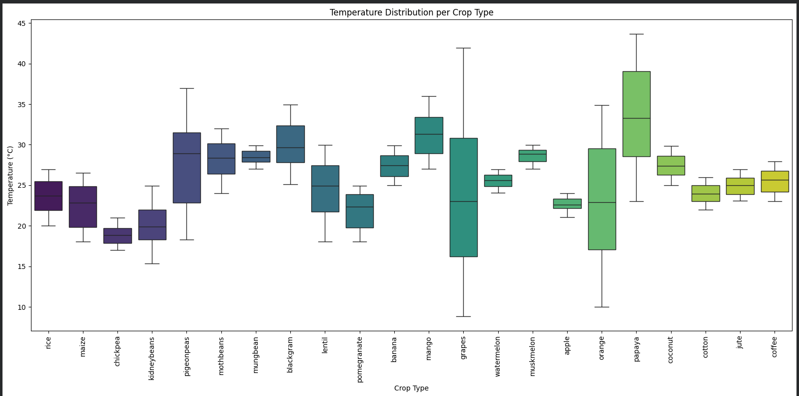
CODE:
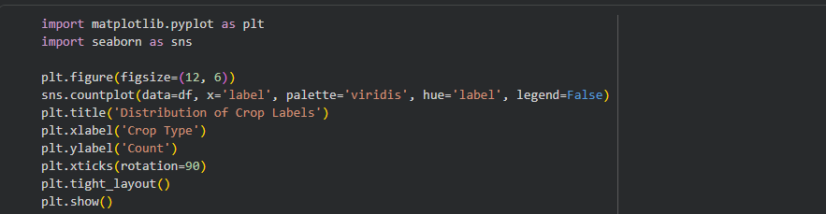
OUTPUT:
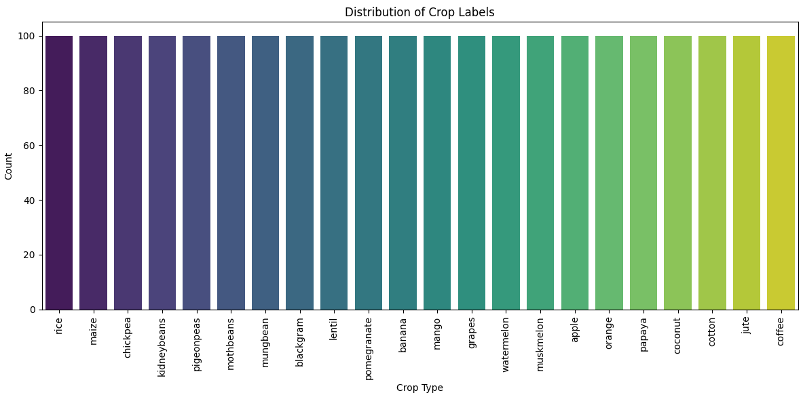
CODE:
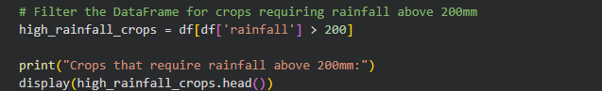
OUTPUT:
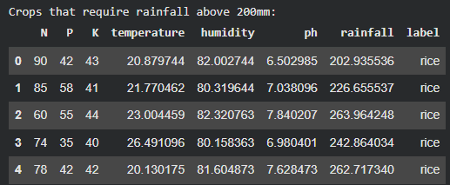
CODE:
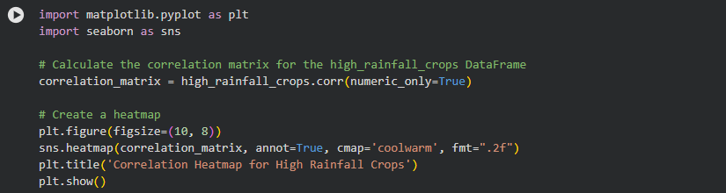
OUTPUT:
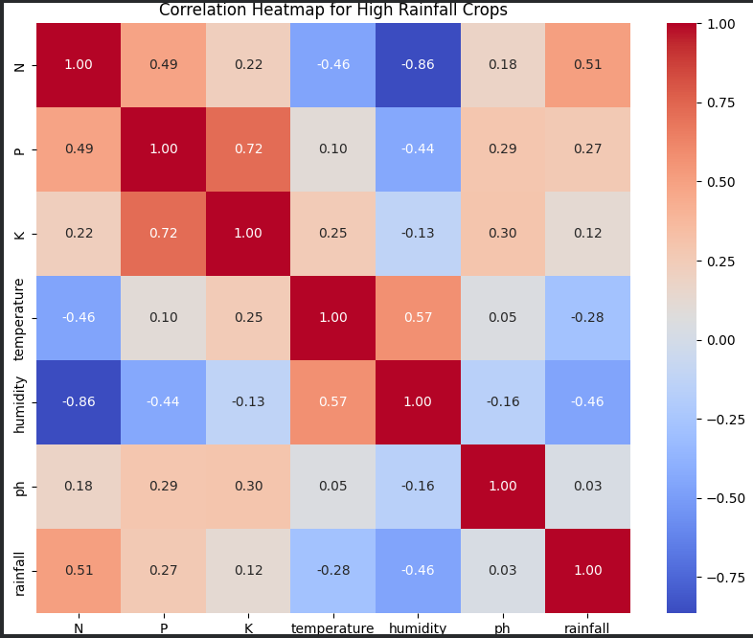
CODE & OUTPUT:
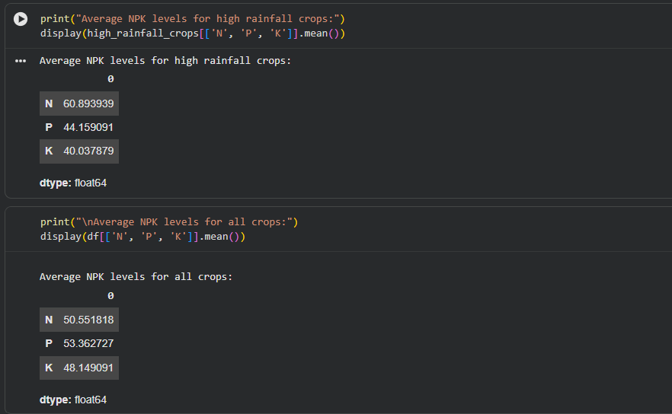
CODE:
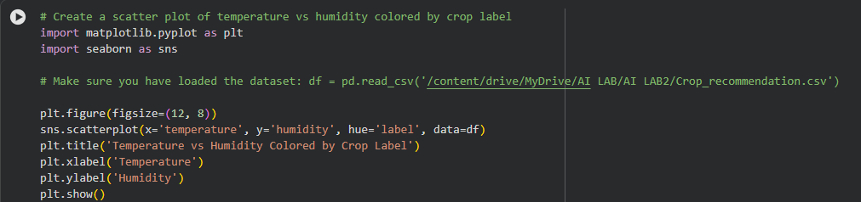
OUTPUT:
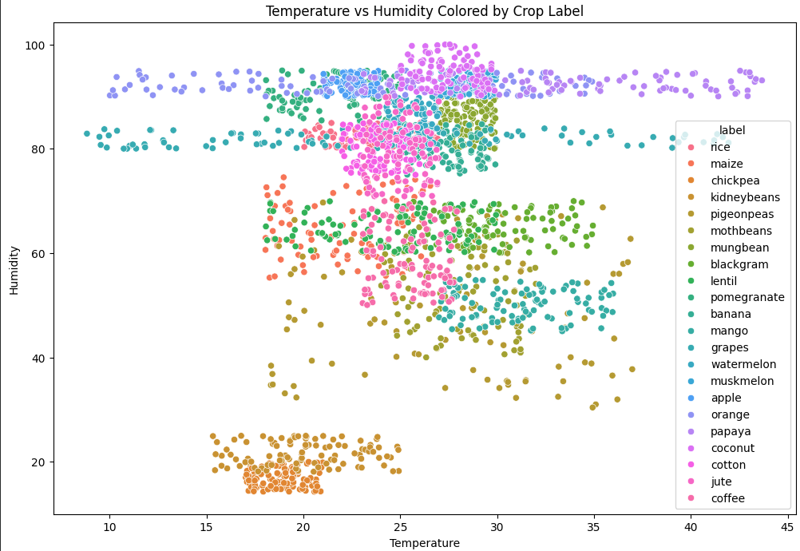
CODE & OUTPUT:
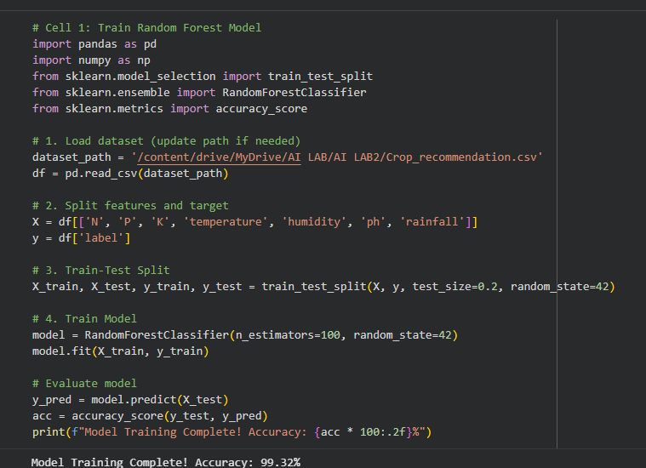

CODE:
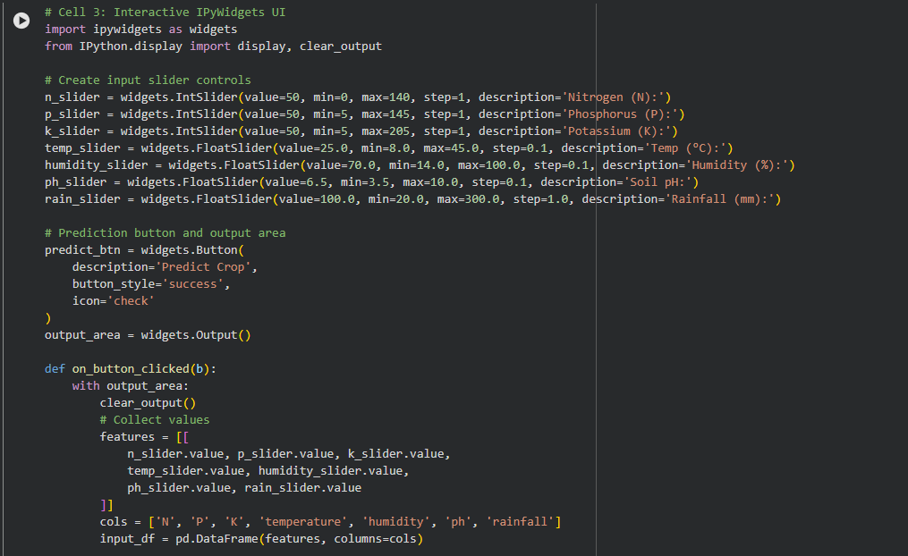
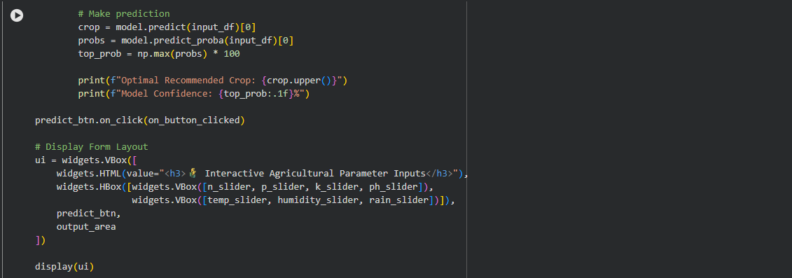
OUTPUT:
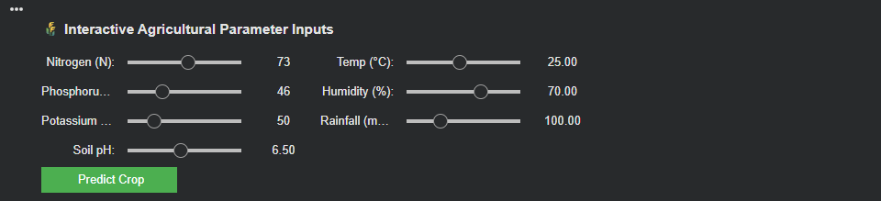
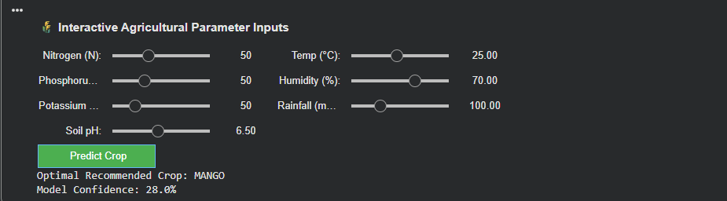
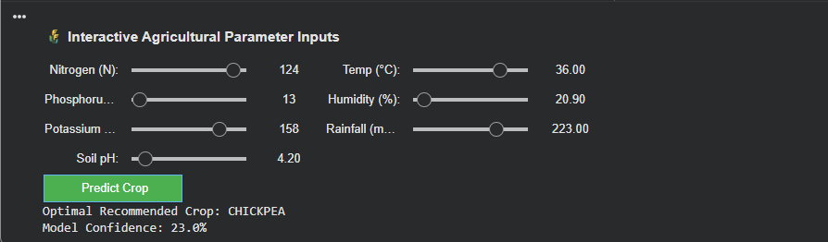
Question 2
Execute a Python-based data-driven crop decision system using the Kaggle Crop Recommendation Dataset to produce an efficient result for a real-world precision-agriculture problem. Demonstrate the use of selected soil and environmental features, including N, P, K, temperature, humidity, pH, and rainfall, to develop a rule-based decision system that generates a suitable crop recommendation or agricultural category. Analyze the generated decisions by comparing the selected input conditions with the patterns present in the dataset and identify the limitations of using predefined rules instead of a trained Machine Learning model. Evaluate how AI-based data-driven decision systems can support farmers and agricultural stakeholders in crop selection, efficient resource utilization, sustainable farming practices, and resilient agricultural decision-making.
The activity addresses PLO-03 (Design/Development of Solutions) and PLO-05 (Modern Tool Usage) and contributes to SDG 9 (Industry, Innovation and Infrastructure) and SDG 11 (Sustainable Cities and Communities) by promoting technology-enabled, efficient, and resilient agricultural decision-making.

Task Requirements
- Select at least three input features from the dataset, such as:
  - Nitrogen (N)
  - Phosphorus (P)
  - Potassium (K)
  - Temperature
  - Humidity
  - pH
  - Rainfall
- Develop a Python function that accepts the selected features as input and generates a meaningful agricultural decision, such as:
  - Suitable / Less Suitable
  - Low / Medium / High soil condition
  - Recommended crop category
- Use if-elif-else, logical operators, functions, loops, and lists to process multiple records from the dataset.
- Generate and display the final decision for at least 10 dataset records and compare the generated decision with the corresponding crop label where applicable.
- Calculate at least one meaningful evaluation result, such as:
  - Number of matching decisions
  - Percentage of matching decisions
  - Number of records in each category
  - Correct versus incorrect decisions
- Analyze at least two limitations of the rule-based system and explain why a Machine Learning model such as Decision Tree, Random Forest, or XGBoost could provide a more systematic predictive solution in later laboratories.
CODE:
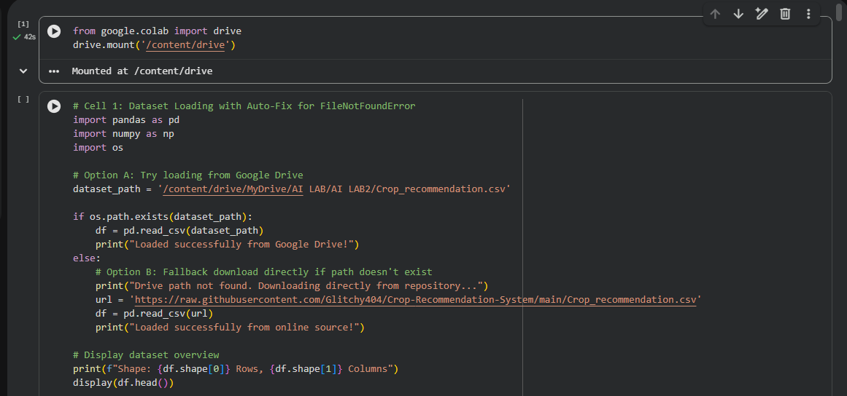
OUTPUT:
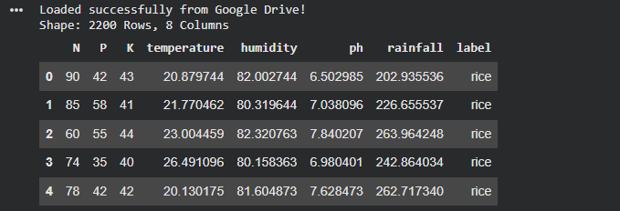
CODE & OUTPUT:
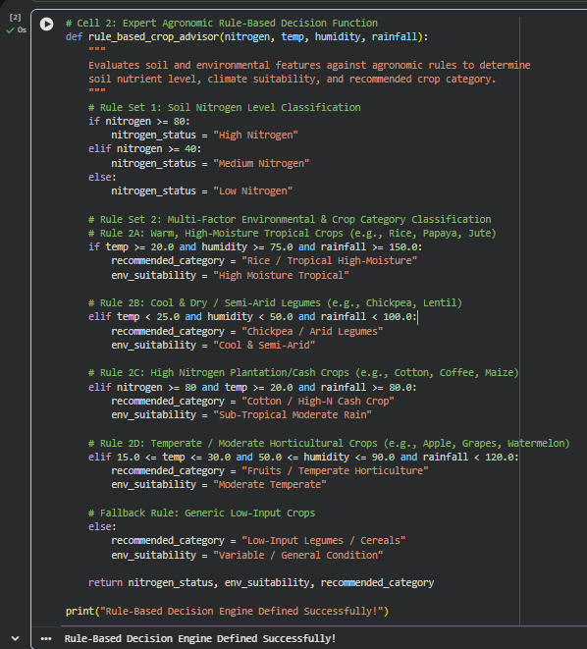
CODE:
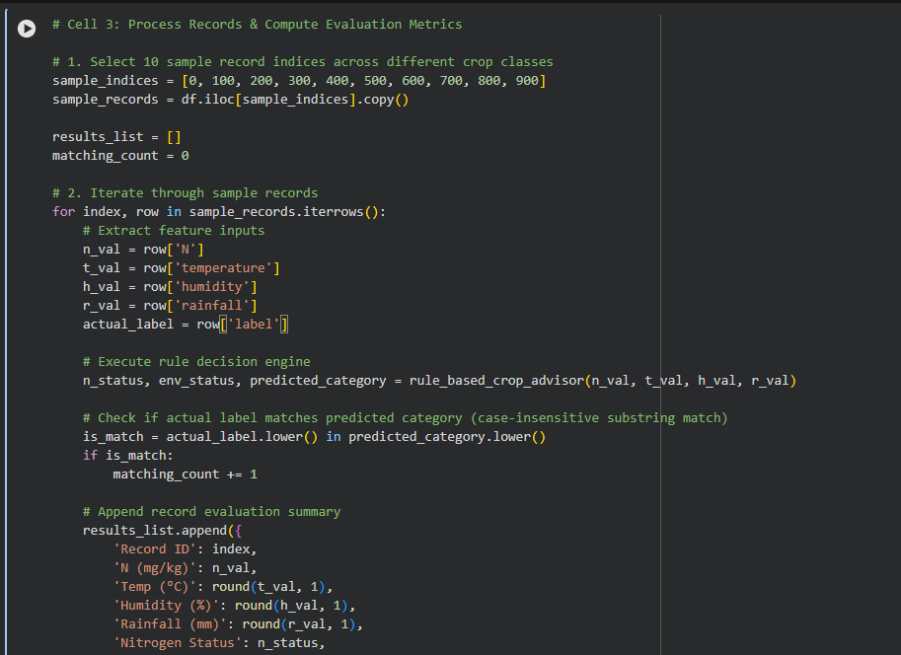
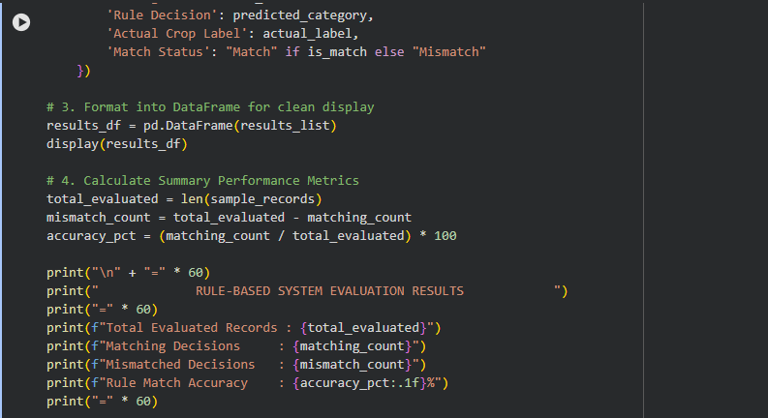
OUTPUT:
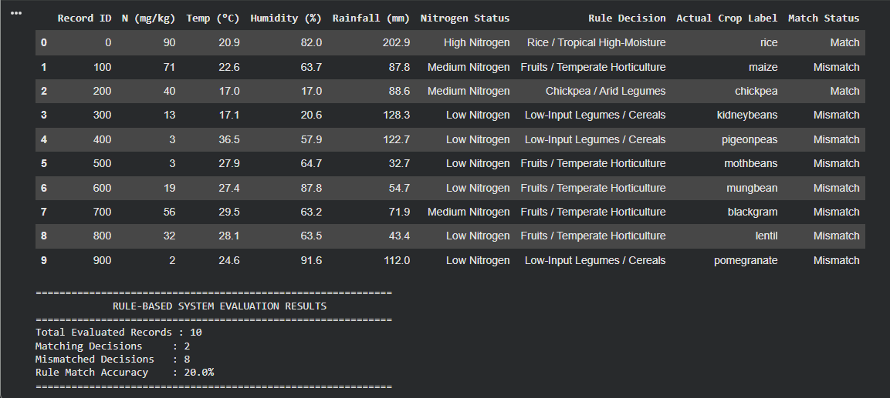

CODE:
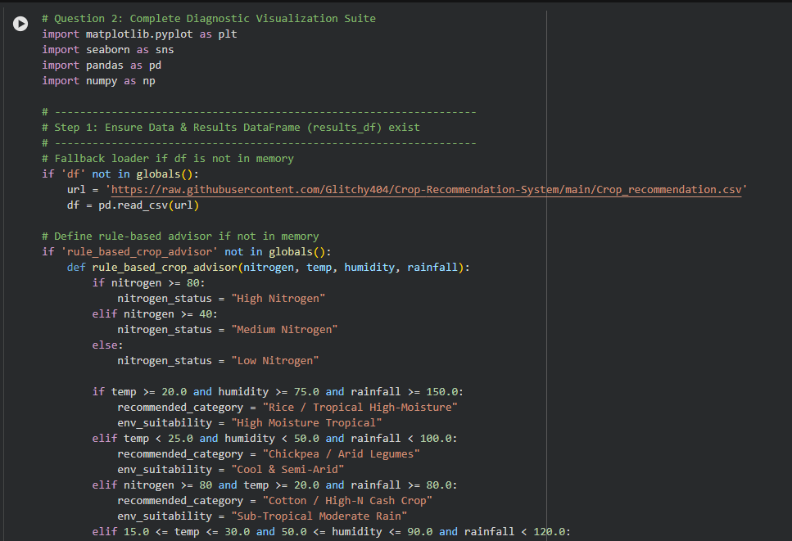
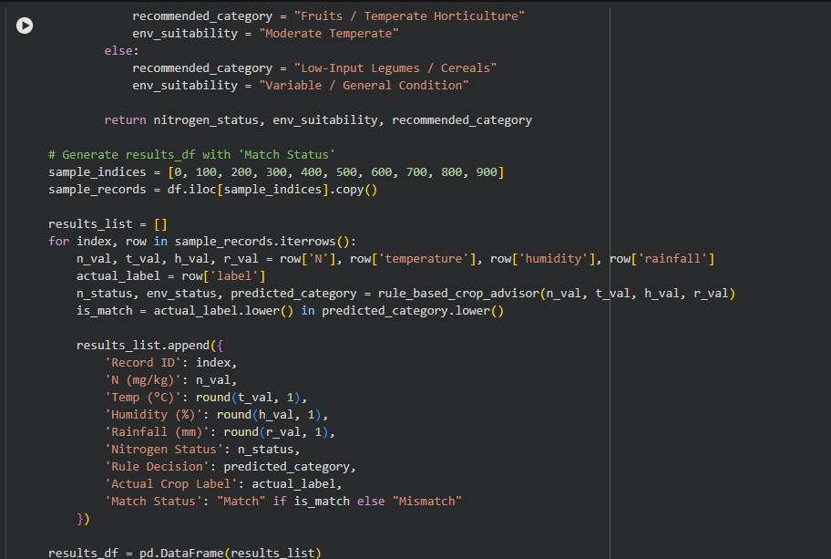
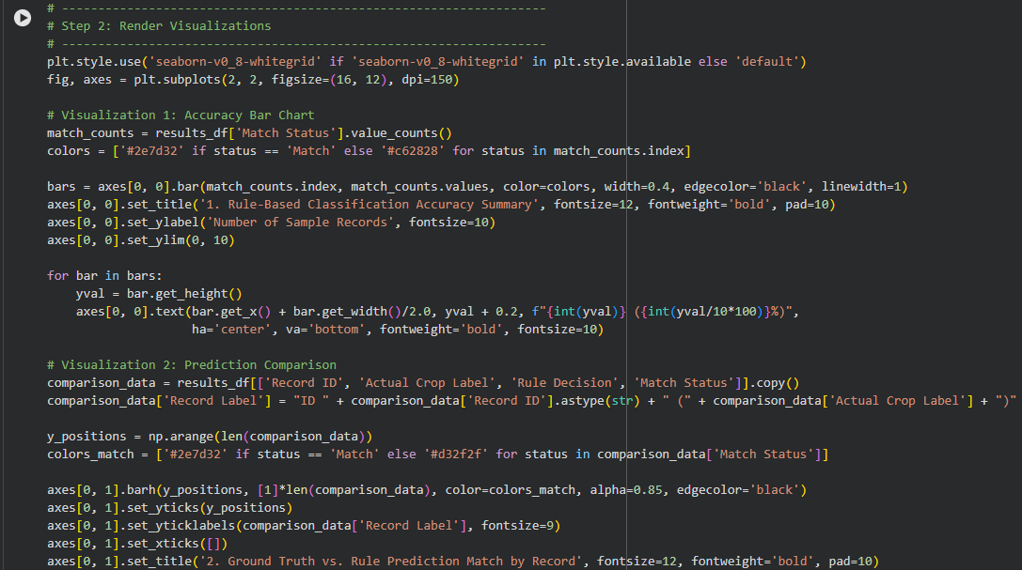
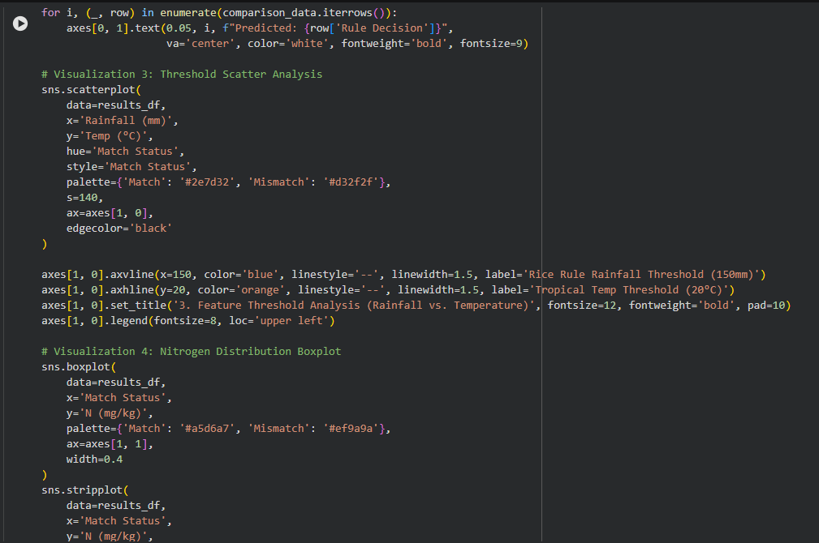
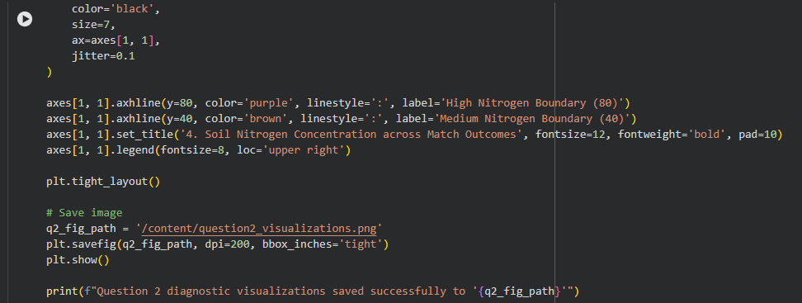

OUTPUT:
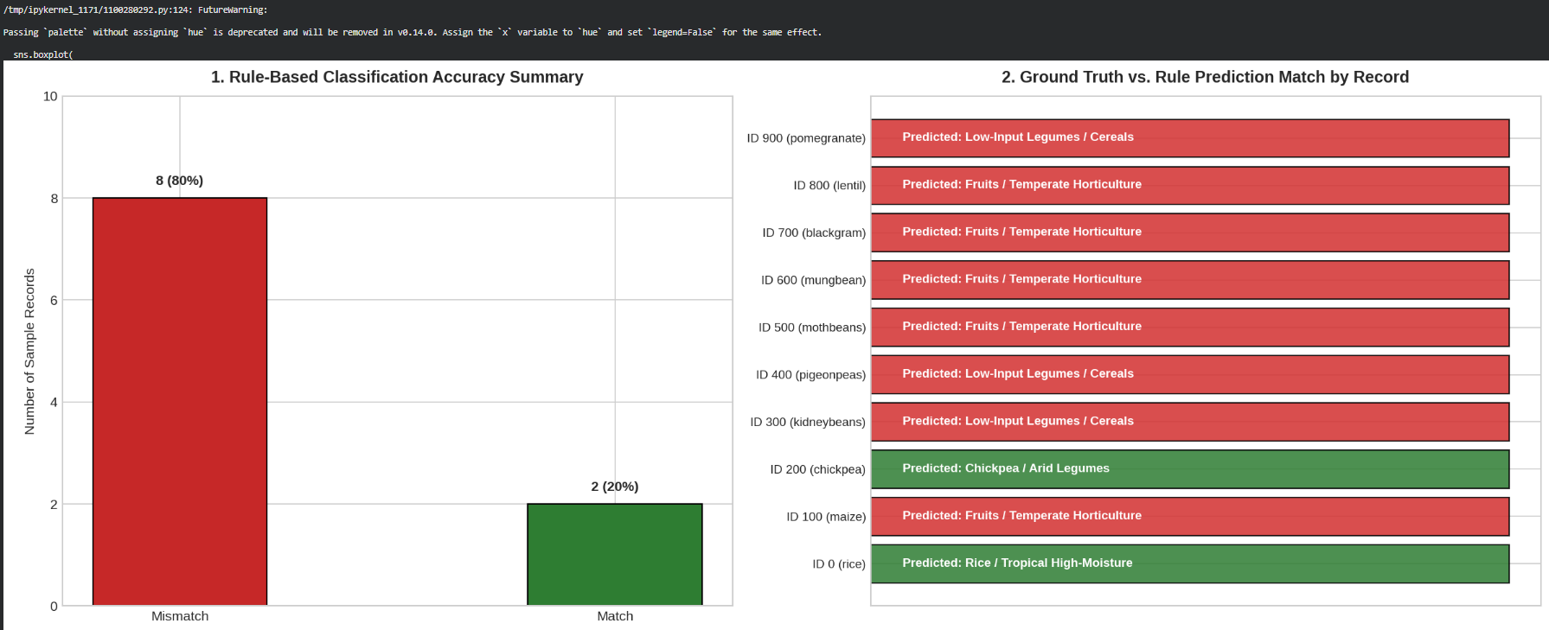
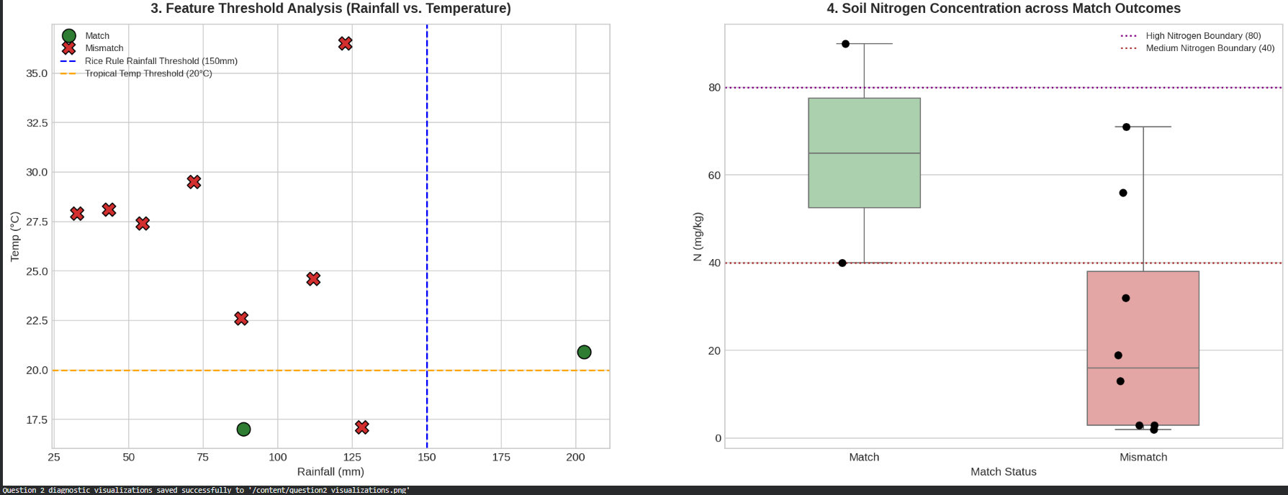

CODE & OUTPUT:
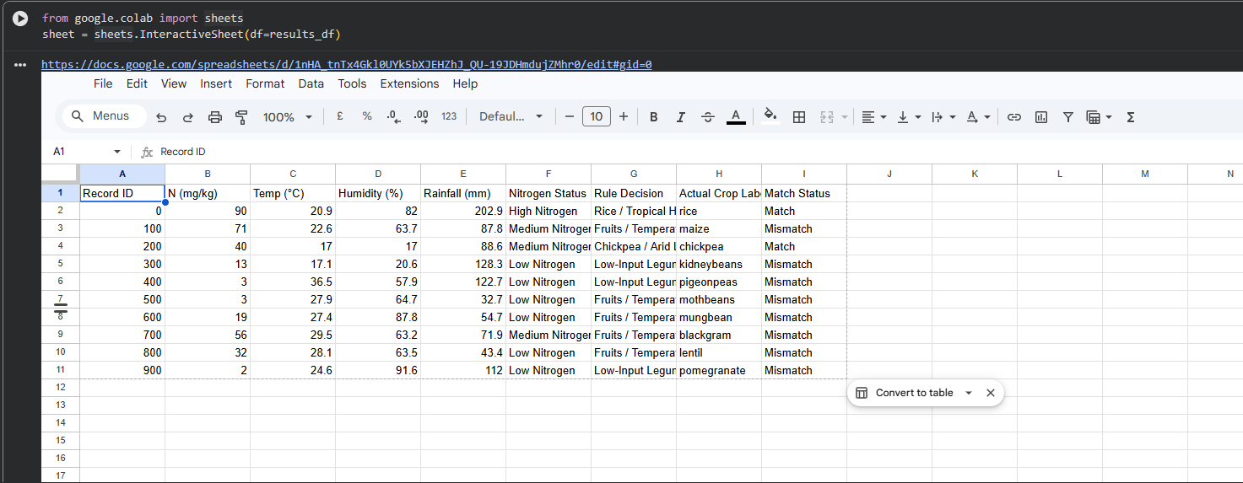
CODE:
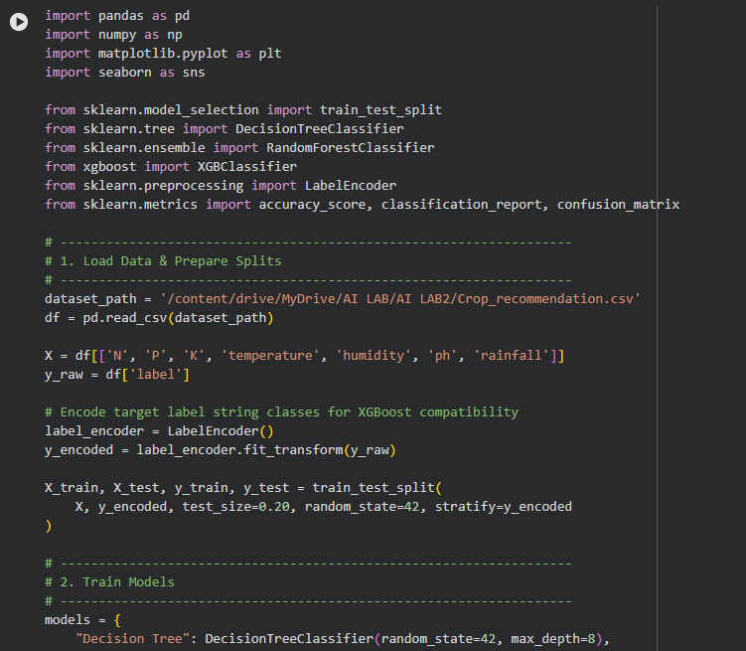
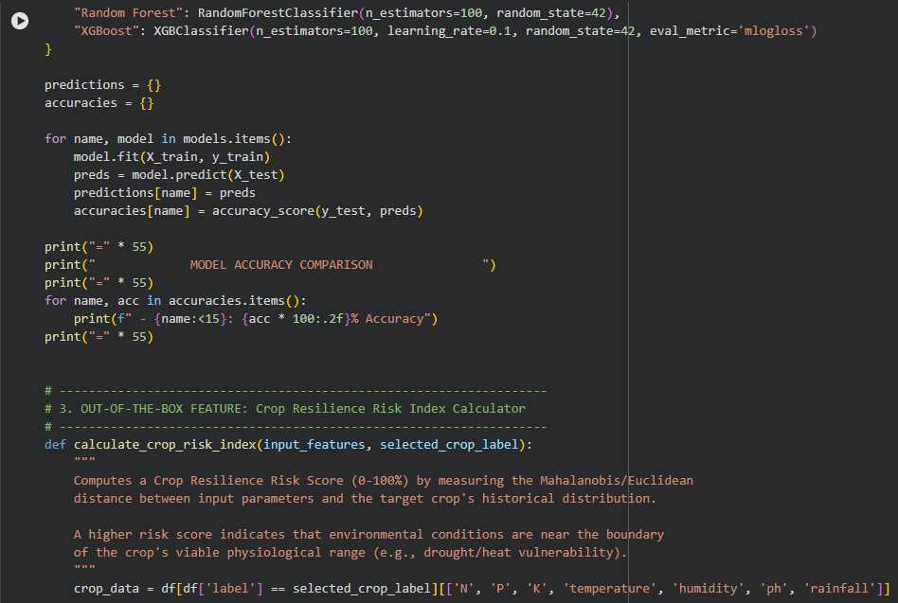
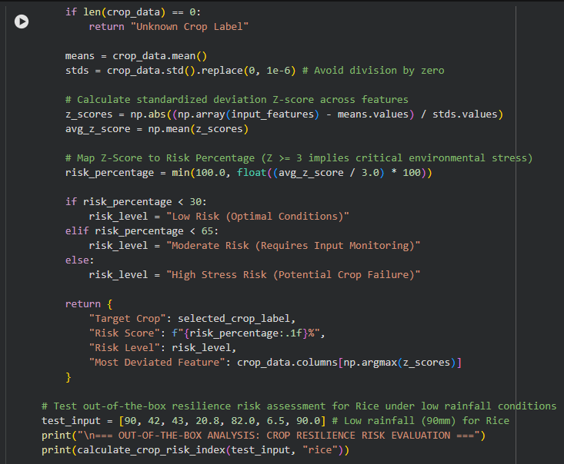
OUTPUT:
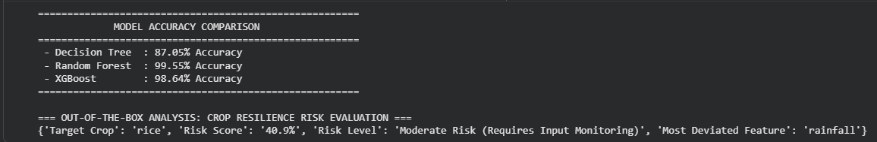
CODE:
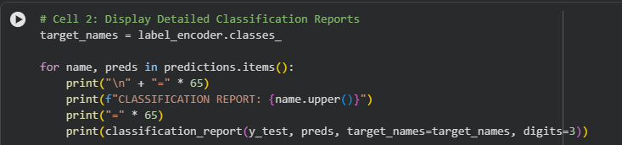
OUTPUT:
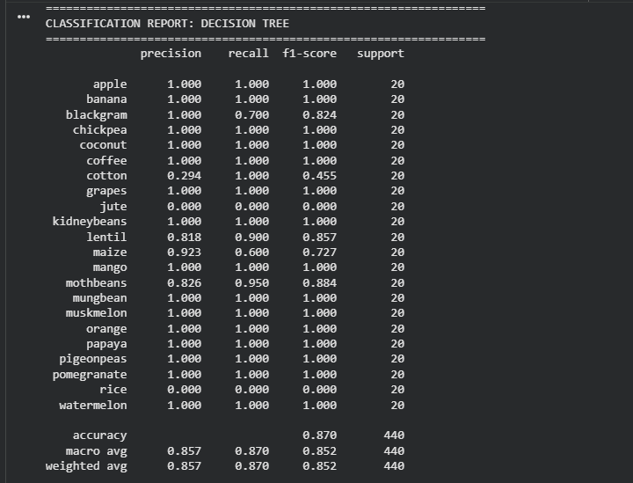
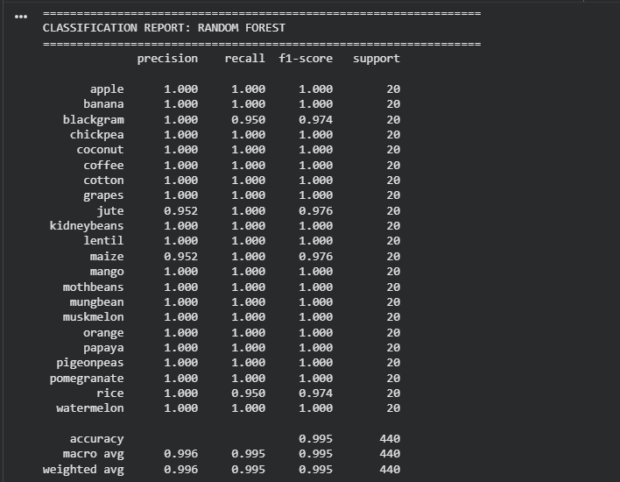
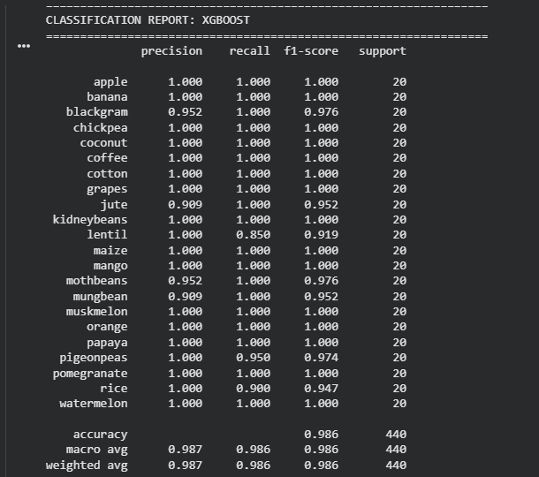
CODE:
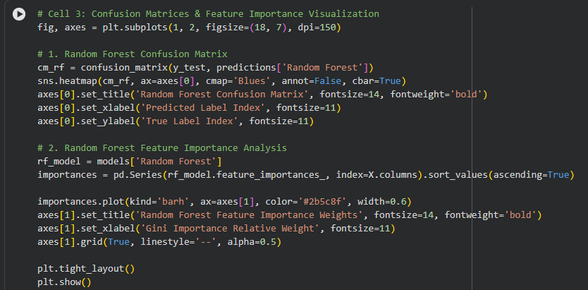
OUTPUT:
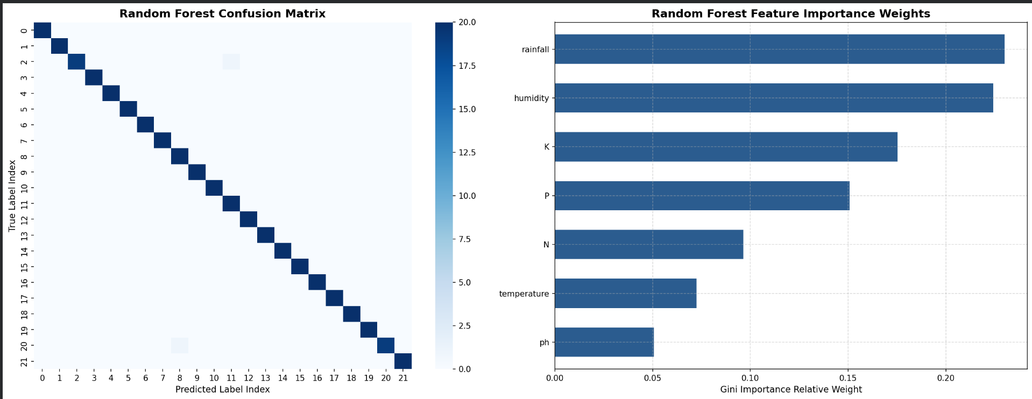
CODE:
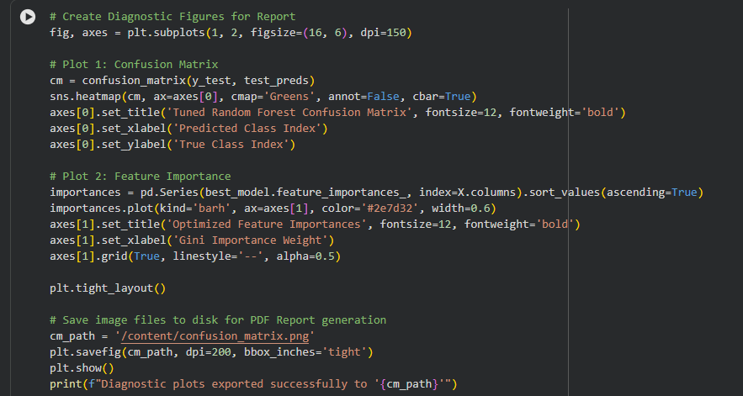
OUTPUT:
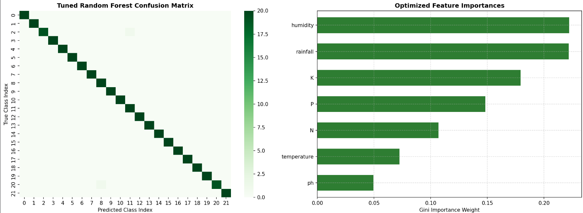

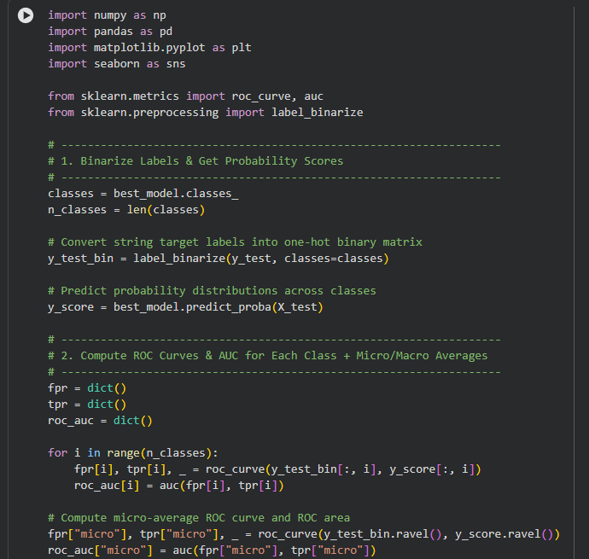
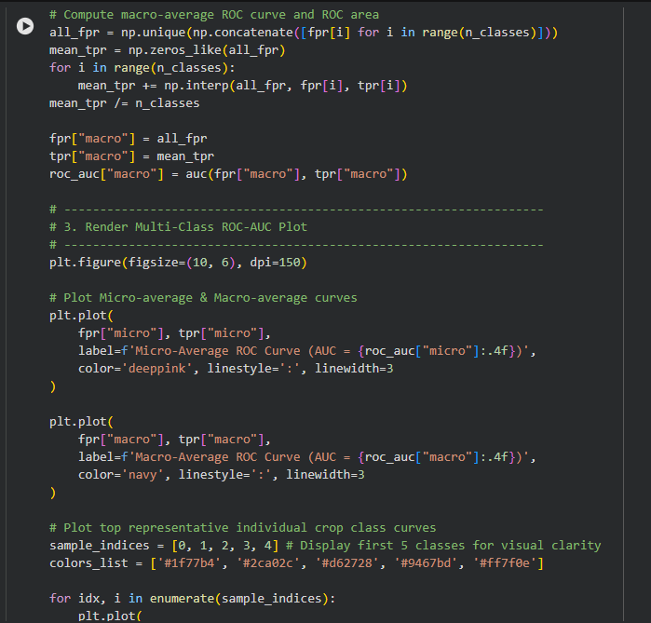
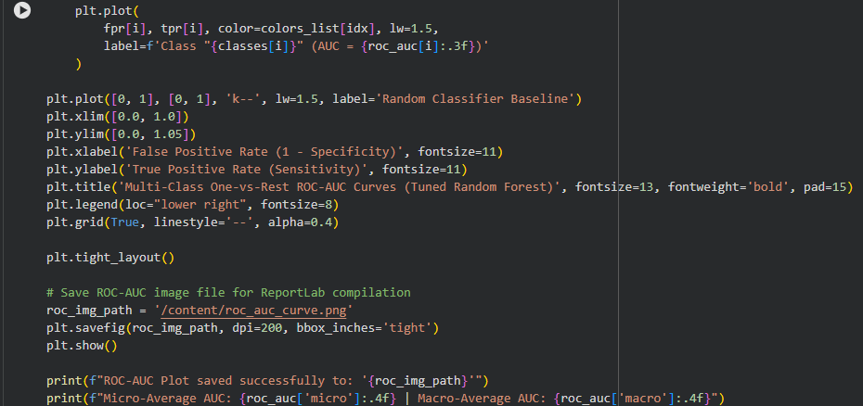
OUTPUT:
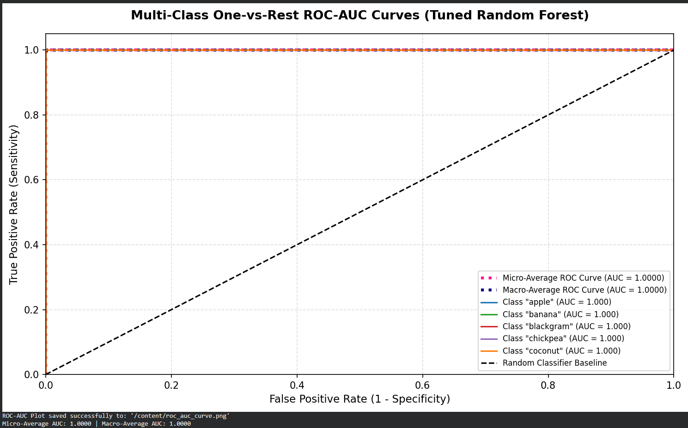
CODE:
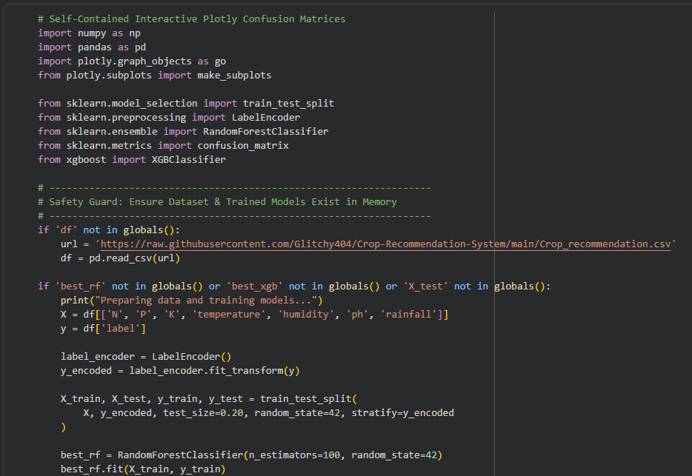
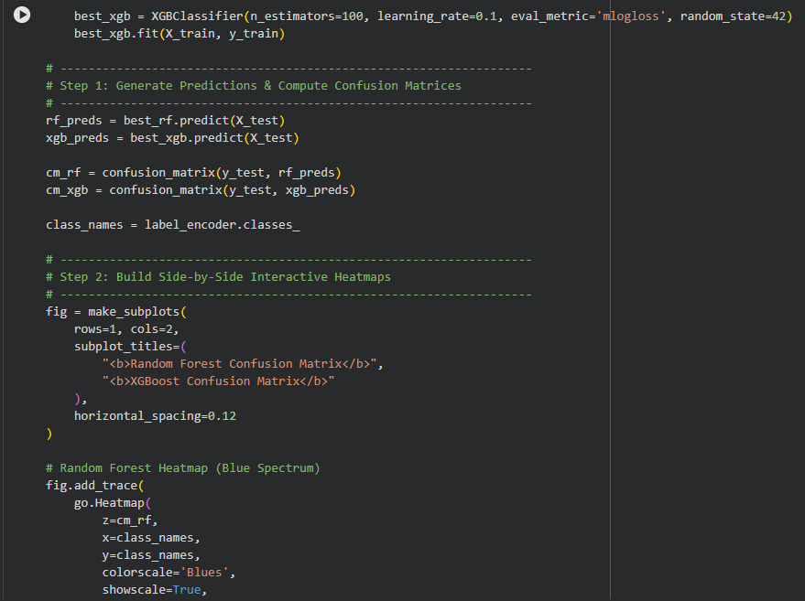
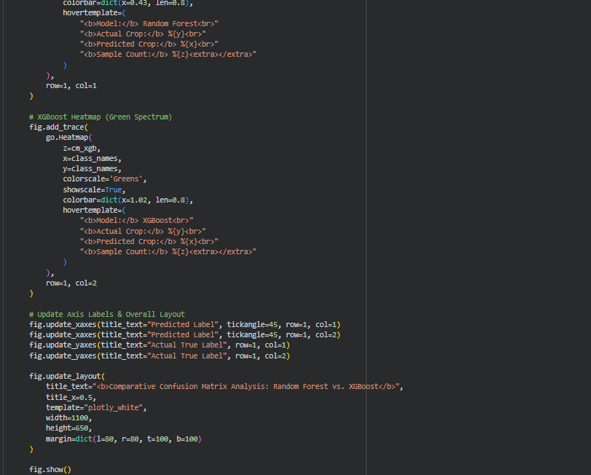
OUTPUT:
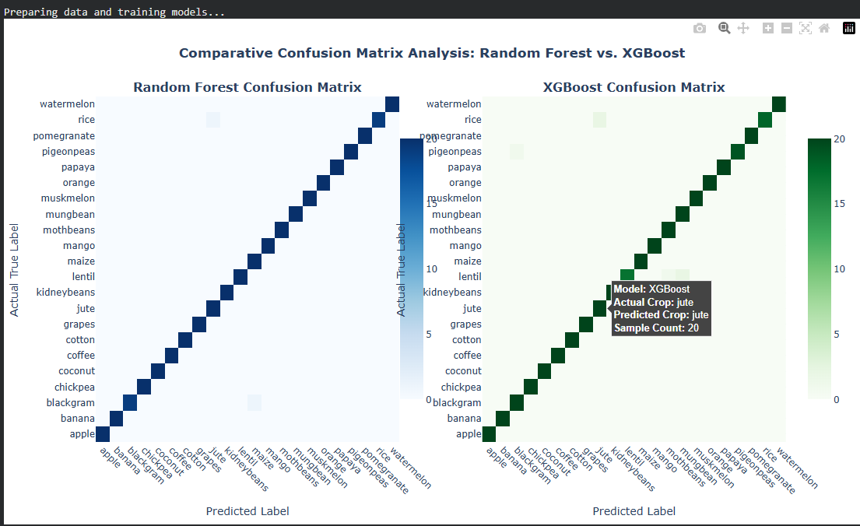
CODE:
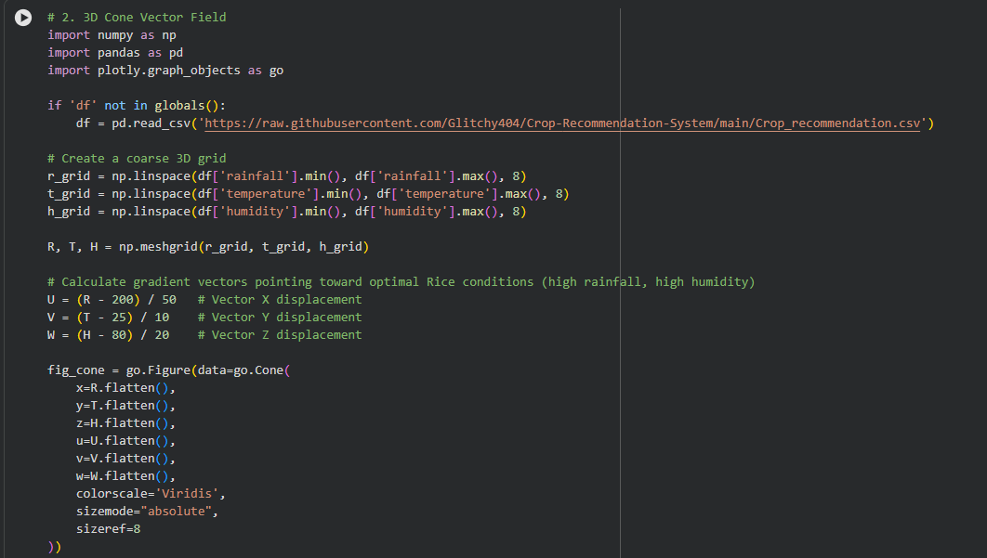
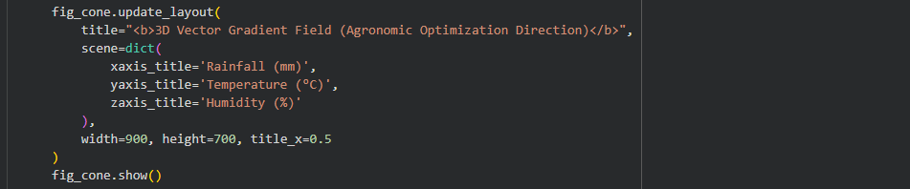
OUTPUT:
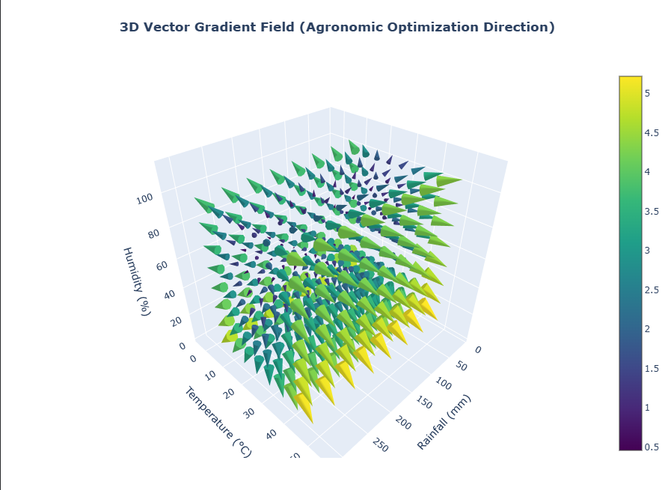

[CLO- 02, PLO-03, P4 (Execute) (WK5, EC4, and SDG 11) Rubric (Syntax, Logic, Completeness, (Outcome) Points (12)]
Rubrics:
Rubric | Exemplary (4) | Accomplished(3) | Developing (2) | Beginning (1)
Syntax points  Ability to understand and follow the rules of the programming language. | Program compiles and contains no syntax errors of the language. | Program compiles and is free from major syntactic errors. | Program compiles, but contains errors that signal misunderstanding of syntax | Program does not compile or (in a dynamic language) contains typographical errors
Logic points  Ability to specify conditions, control flow, and data structures | Program logic is correct, with no known boundary errors | Program logic is mostly correct, but may contain an occasional boundary error | Program logic is on the right track with no infinite loops, but shows no recognition of  boundary conditions | Program contains some conditions that specify the opposite of what is required (less than vs. greater than)
Completeness  Points  Ability to apply rigorous case analysis to the problem domain. | Program shows evidence of excellent case analysis, and all possible cases are handled appropriately. | Program shows evidence of case analysis that is mostly complete, but may have missed minor or unusual cases. | Program shows some evidence of case analysis, but may be missing significant cases or mistaken in how to handle some cases. | Program shows little recognition of how different cases must be handled differently.

